Legislative Committee Meeting
Tuesday, January 28, 2025
1 pm

Virtual meeting held via ZOOM: link below

https://us02web.zoom.us/j/8973632718?omn=85042483018

- Welcome and CT Updates

- Review House 1
 | FY 2025 Final | FY 2026 House 1 | Difference
3000-2050 Children's Trust Operations | 2,741,367* | 1,797,197 | -944,170
3000-2060 Child Sex Abuse Prevention | 2,351,044 | 2,293,185 | -57,859
3000-7000 Healthy Families | 17,684,101 | 17,642,897 | -41,204
Total | 22,776,512 | 21,733,279 | -1,043,233
*includes 350,000 PAC for move in FY25

- Discuss Upcoming Legislative Events

- Set Next Meeting Date

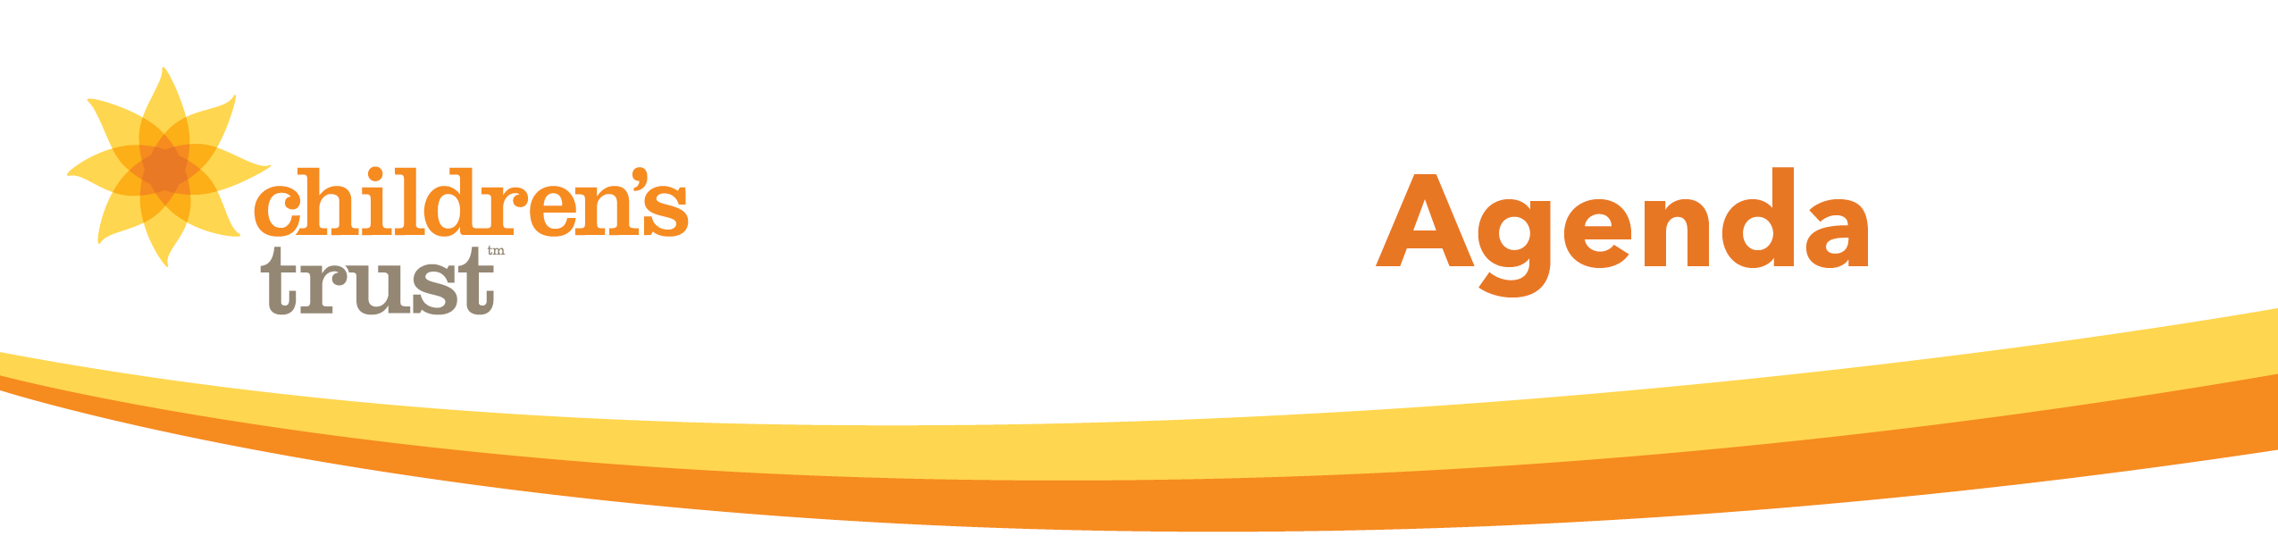
- Close

